**OUTREACH SCHOOLS EXAMINATIONS BOARD**

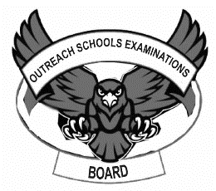 **END OF TERM I EXAMINATION 2024**

**PRIMARY TWO**

**ENGLISH**

**My name is ………………………………………………….……………………**

**I am in …………………….…………….…..………………….………………….**

**My school is ……………….…………….………………………………………**

**SECTION A**

**1. Fill in missing letters.**

m ….. Th….. r s…..gn post rul…..r carp…..nter

2. **Give the opposite for the word in the brackets**.

I am a ……………………………………….. child. (bad)

Tom has a ……………………………………….. ball. (small)

Micheal is a tall ……………………………………….. (girl)

We ……………………………………….. to school every day. (come)

3. **Write the words in small letters**.

BENCH…………………………………………………..

AUNT…………………………..………………………..

UNFORM………………………………………………..

MEAT……………..……………………………………..

4**. Fill the gaps with “a” or “an”**.

This is ………………………………………..elephant.

She has ………………………………………..red skirt.

Do you like………………………………………..apple?

…………………………………………owl has very big eyes.

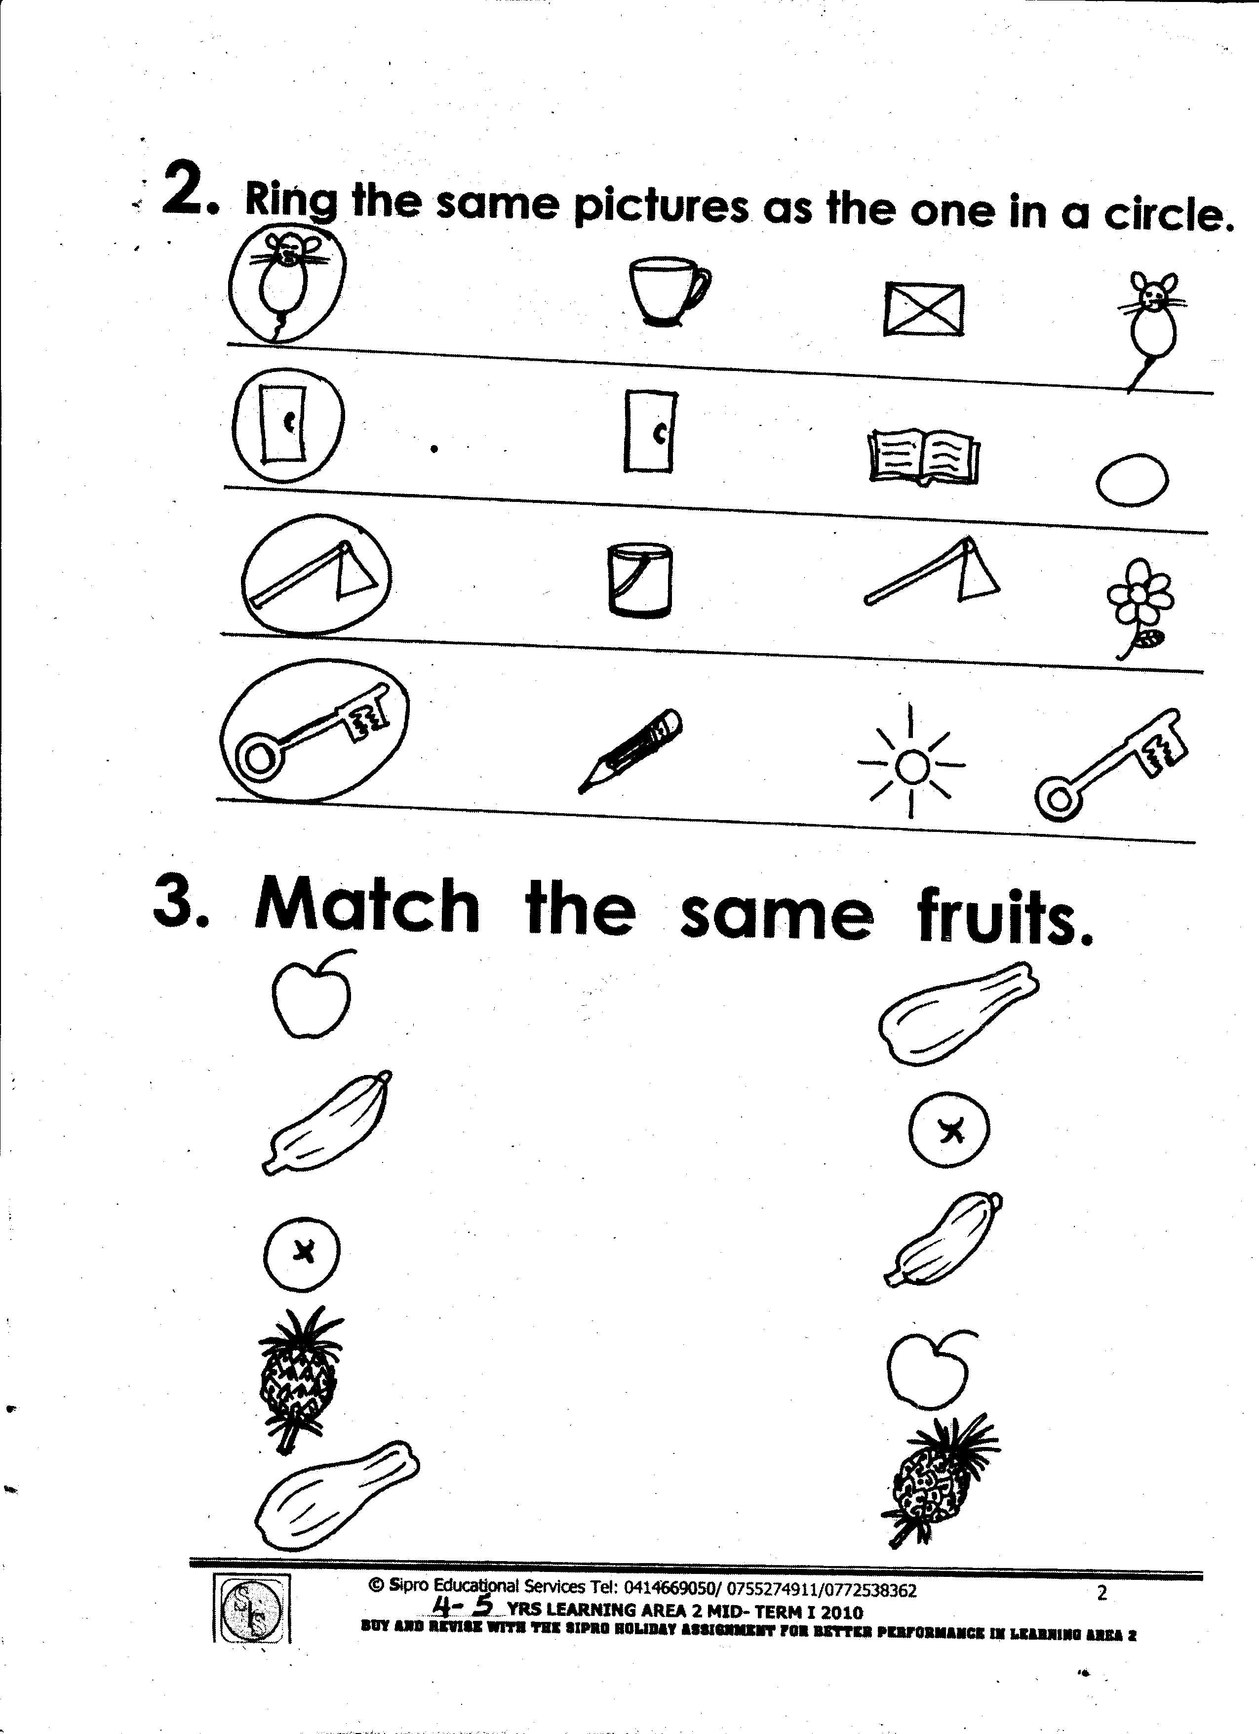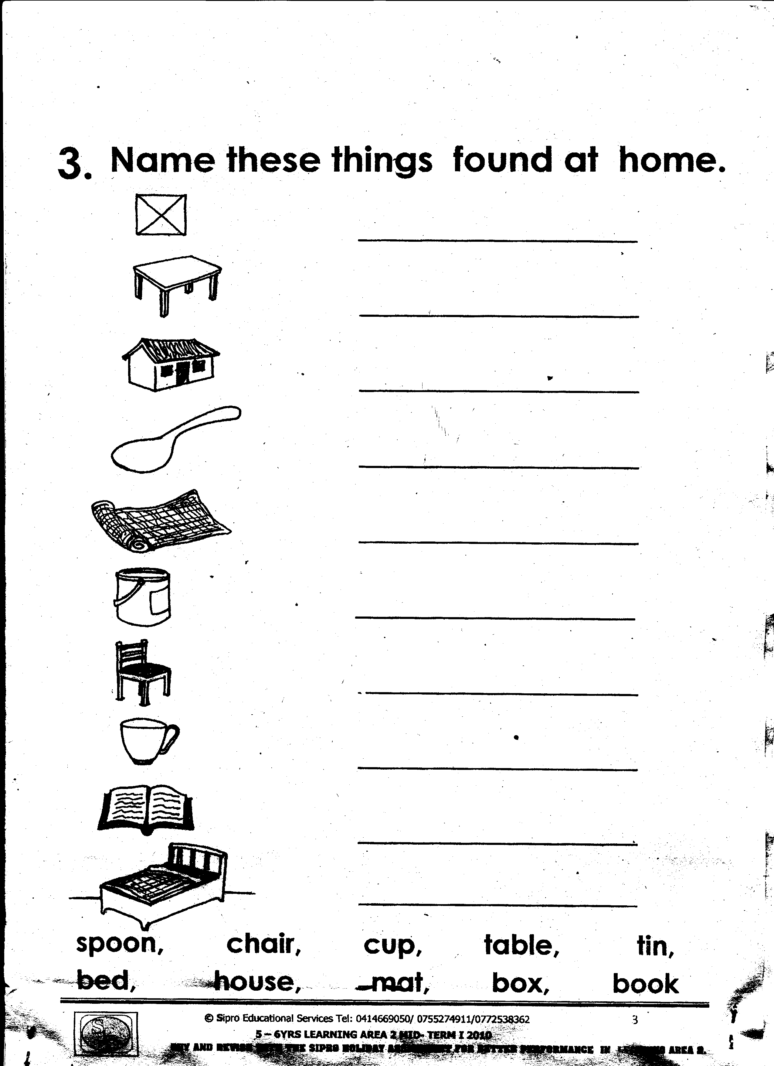5**. Name the pictures**.

|  |  |  |
| --- | --- | --- |
| 1E1EF371 |  |  |
|  |  |  |

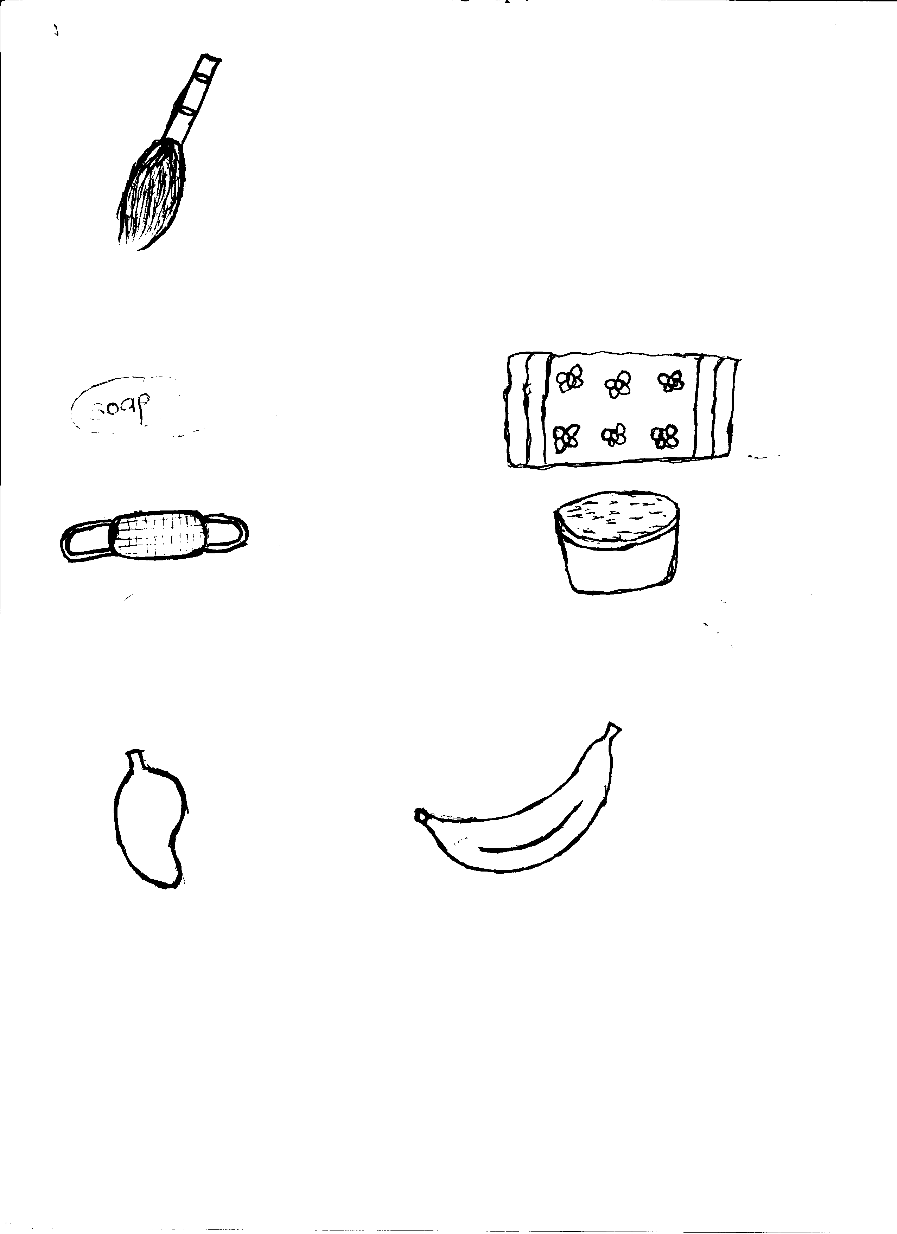6. **Answer Yes, it is / No it is not**.

Is this a broom?

……………….…………………………………………………………………………..

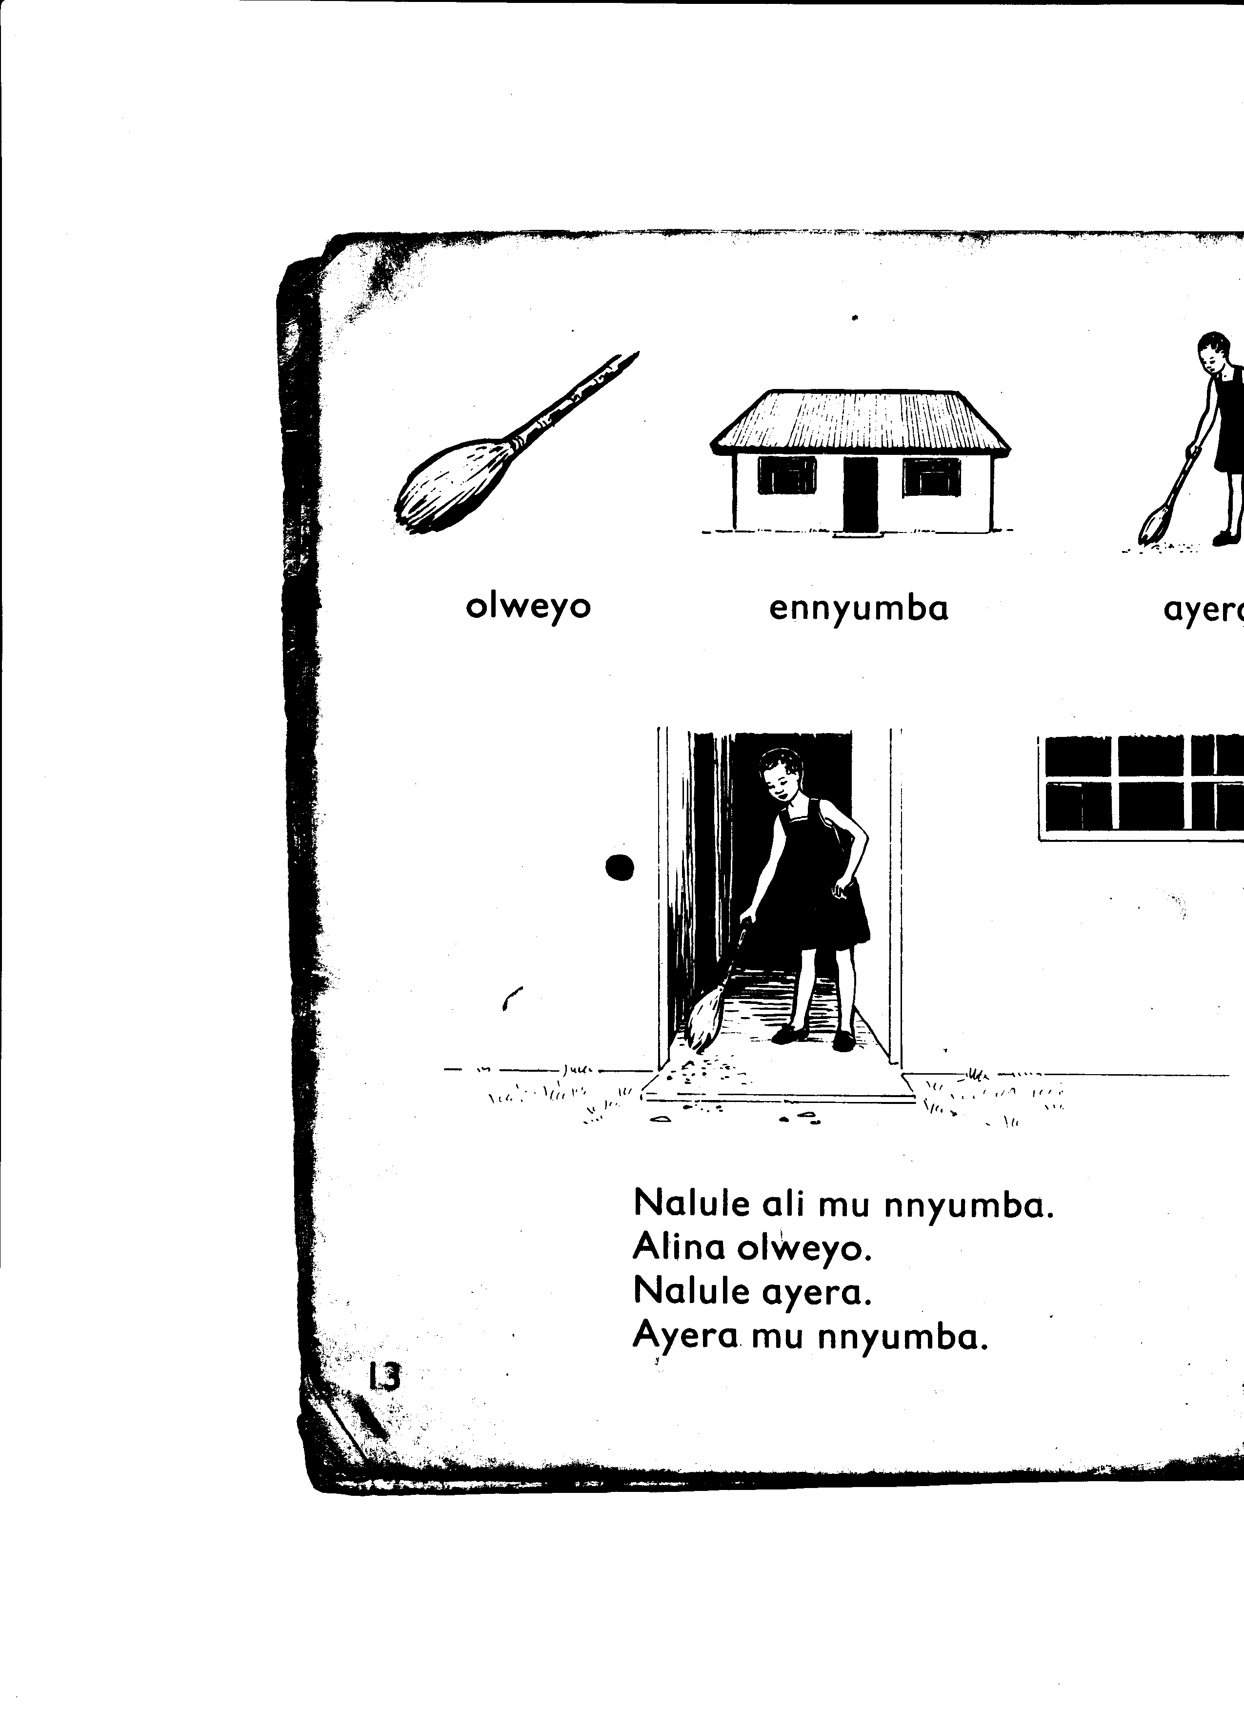 Is this a cup?

…………………………………………………………..……………………….…..

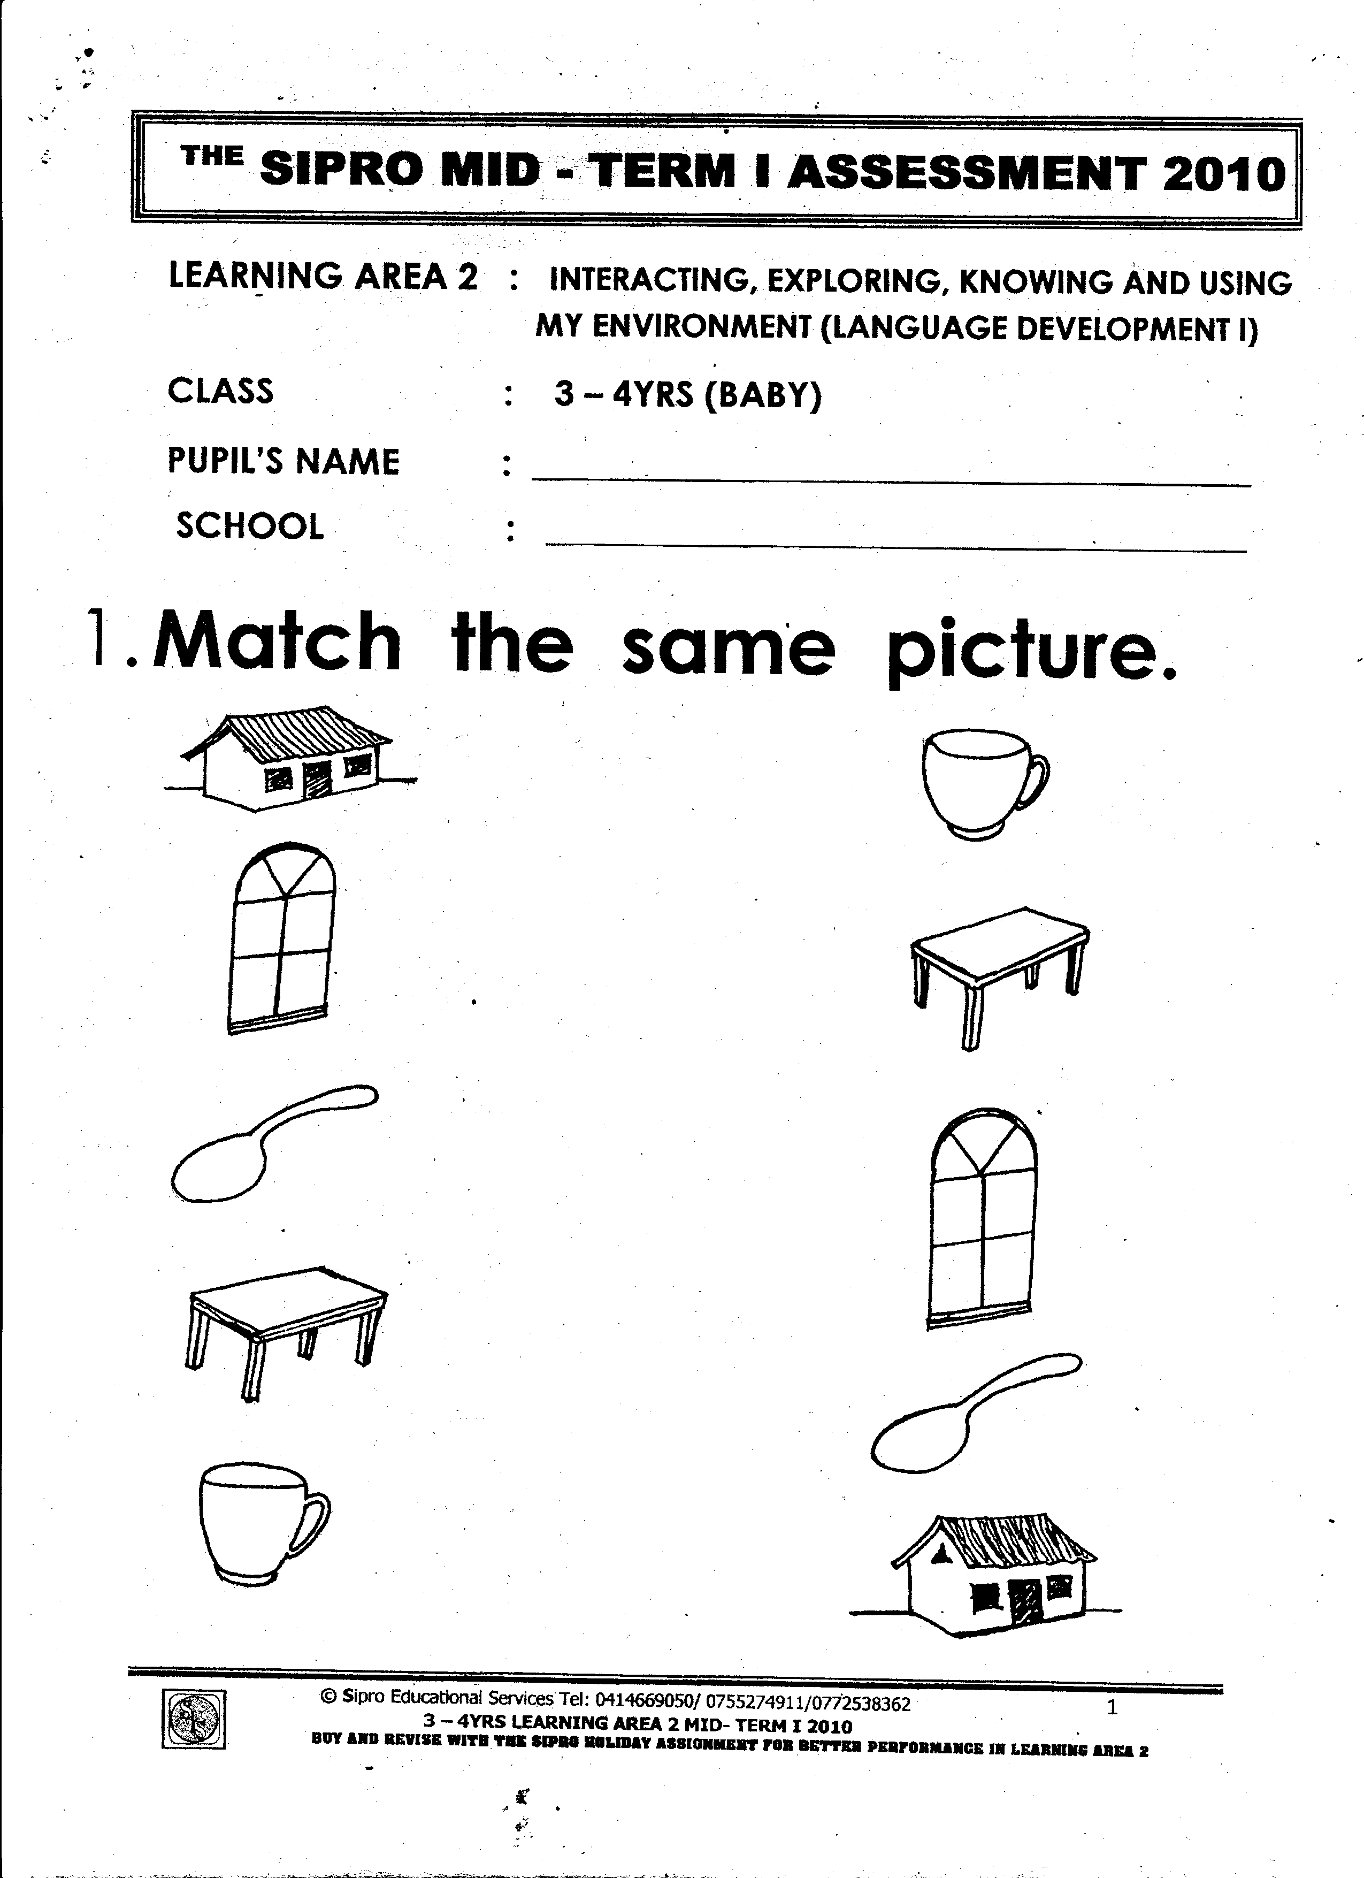

Is this a pencil?

………………………………………………………….…………………….…..

7. **Add ing to the word in the brackets.**

They are ……………………………………….. in their books. ( write)

She is ……………………………………….. at the flowers. ( look)

Maria is ……………………………………….. a rope. ( skip)

C:\Program Files\Microsoft Office\CLIPART\PUB60COR\J0105396.WMF8. **Fill the gaps with the correct word.**

The flower are……………………………………….. the vase.

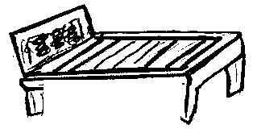

The box is ……………………………………….. the bird.

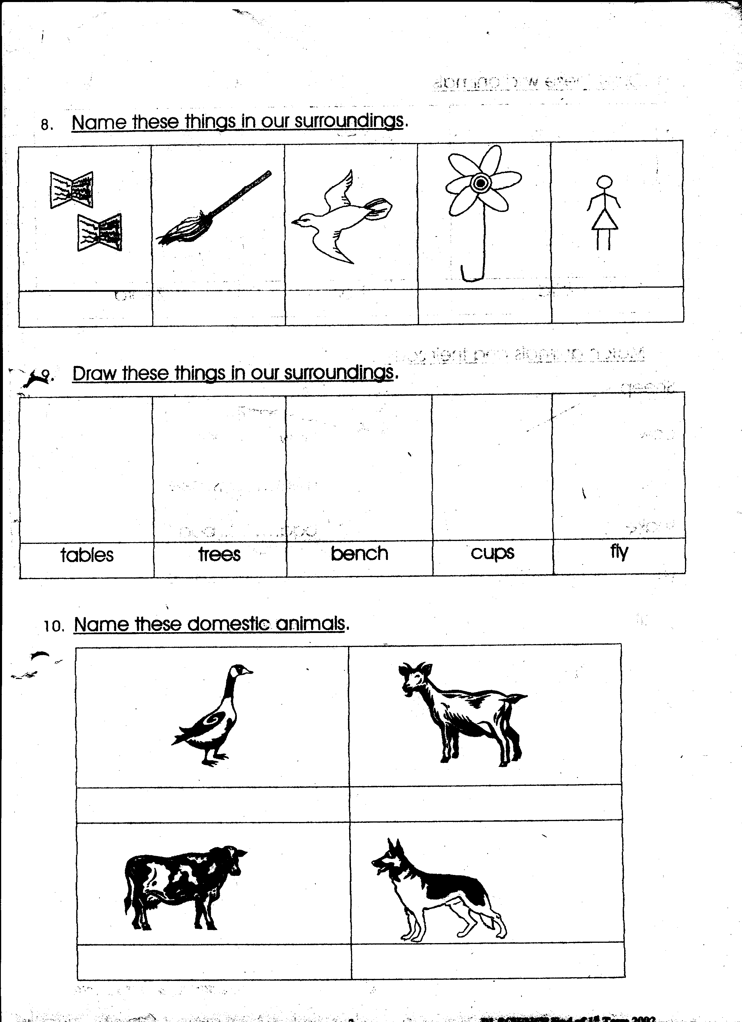

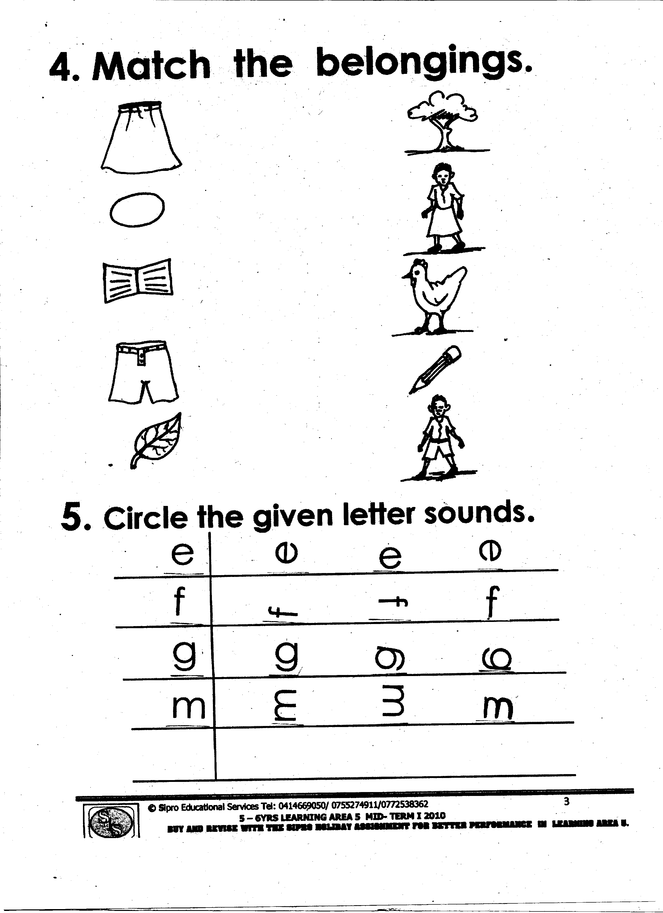 The bird is flying……………………………………….. the tree.

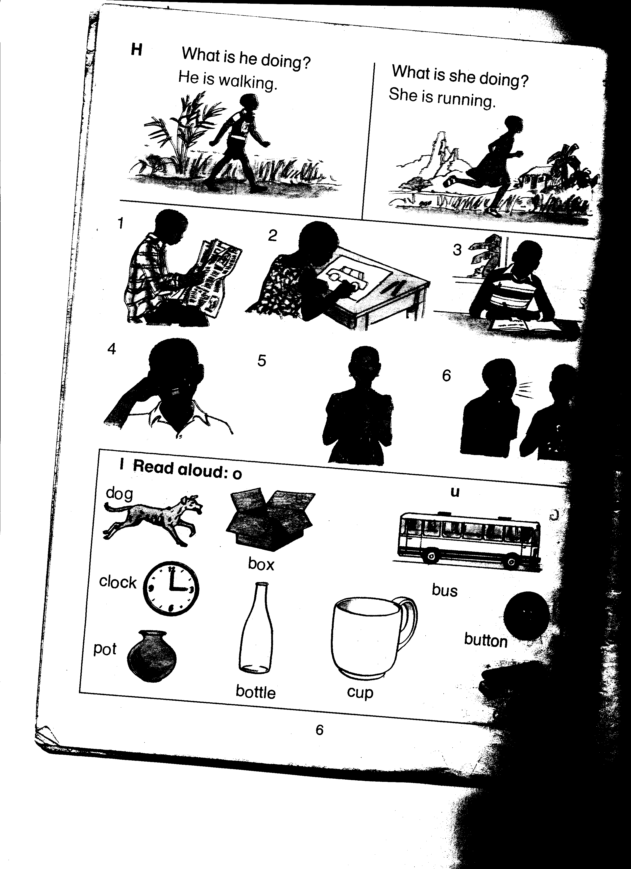

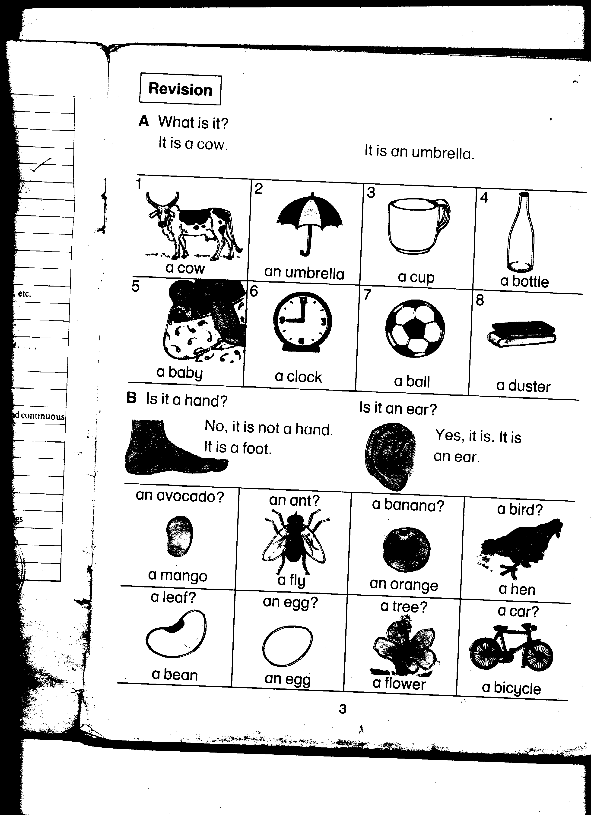 The ball ……………………………………….. the bottle.

9. **Name the people who do this work**.

Teaches children…………………………………………………………….…………………….........

Heads a school……………………………………………………………………………………….........

Grows crops and keeps animals…………………….……………………………………….........

Treats sick people………………………………………………………………..……………….........

10. **Arrange the words in alphabetical order**.

uniform, motto, anthem, badge.

………………………………………………………………………………………..............................

yellow, pink, blue, red.

…………………………………………………………………………………………………………………..

11. **Write the plural of the underlined word**.

The box is on the table.

…………………………………..…………………………………………………………………….........

I have a long ruler.

……………………………………………………………………………………….............................

Her baby was crying.

……………………………………………………………………………………….............................

Do you brush your tooth?

…………………………………………………………………………………………………………………..

12. **Write the number name**.

I have…………………………………………. eyes ( 2 )

Musa bought………………………………………….pencils. ( 8)

Eva has ………………………………………….brother ( 6 )

13. **Fill the gaps with has or have**.

They ………………………………………….gone to school.

She ………………………………………….done good work.

I ………………………………………….a new uniform.

John ………………………………………….a red a bag.

14.**Make for correct sentence from the table**.

|  |  |  |
| --- | --- | --- |
| I  They  she | is  am  are | playing.  singing.  dancing |

1. ………………………………………………………………………………………………..….………….

b) ……………………………………………………………………………………………………………….

c) ………………………………………………………………………………………………..….………….

d) ………………………………………………………………………………………………..…..………….

**Good luck**